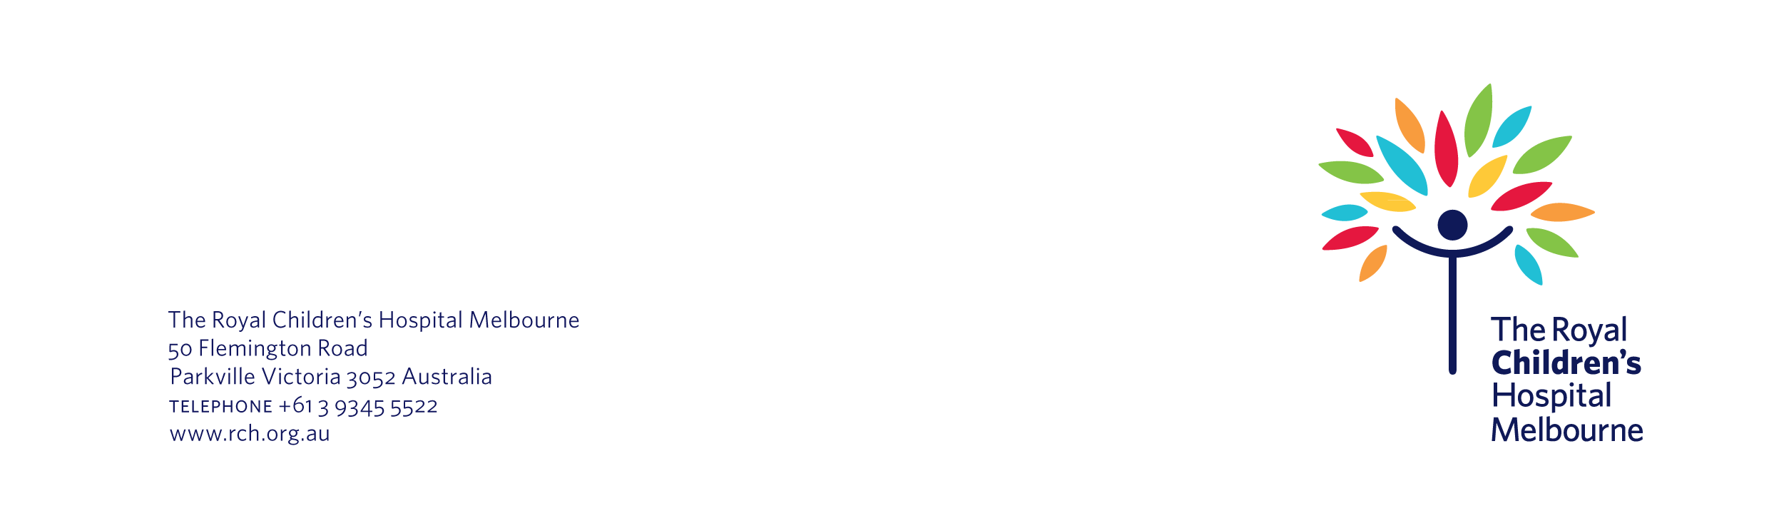

Number / Street Name
Suburb
State / Postcode

Date

Would you like to take part in a research project at The Royal Children’s Hospital?

Dear <insert name>,

I am writing to let you know about a new research project that is taking place at The Royal Children’s Hospital. To ensure your family’s privacy, I am writing on behalf of the research team. The project is about <insert plain language description>. You and your child may be interested in taking part in this project.

Why am I contacting you?

I am sending you this information because <you agreed to be contacted about a new research project about <insert name>> Or <Your child was recently treated in the <insert name of department>. Your child has <insert condition> and may be suitable to take part in the research>.

What is the research project about?

The researchers want to find out <insert brief description of the aims of the project>.

I have enclosed an information statement and consent form about the project. The form explains the research in more detail, including:

- what it involves for you and your child
- the risks and benefits of participation
- what happens to you and your child’s information.

What happens next?

The researchers would be grateful if you would consider taking part in the project. The information statement and consent form will help you make a decision about this.
Please contact the research team to let them know whether you are interested in taking part. You can contact <insert name> on <insert phone number>. You can also email them on <insert email address>.

It is up to you whether you and your child take part in this research project. Your decision will not affect any current or future treatment or your relationship with me.

Thank you for your time.

Kind regards

Name
Department
The Royal Children’s Hospital

